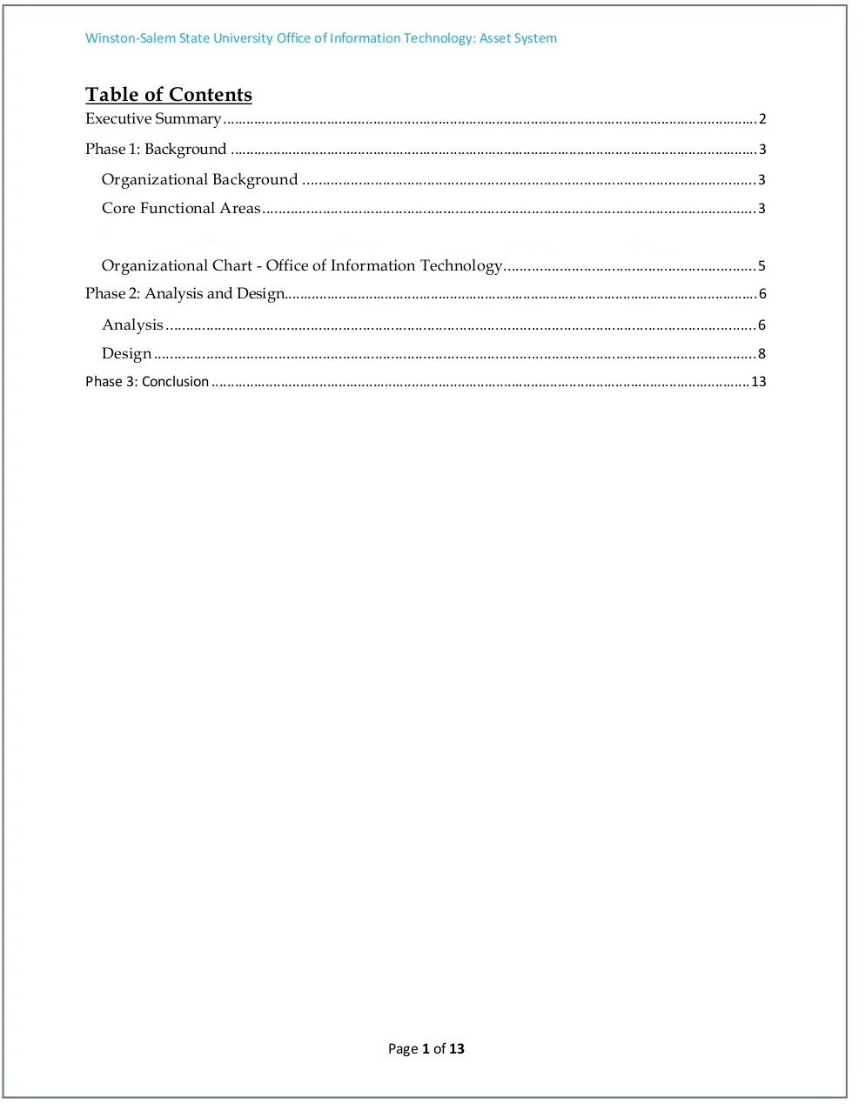

Executive Summary

This documents purpose is to analyze and design an inventory system that is used by the Office of the Control, on the campus of MSA University. By using several Systems Analysis and Design concepts, readers should gain a full understanding of the process and the choices that were made for the project. Foremost, the history of the University and the Office of the Control, is explained to familiarize the reader about the organization and its current format. After which, the entire analysis process is clarified, from the beginning to ending stages, including methods and findings. The design stages of the project then follow this, and are supported by the presented diagrams. Finally, the conclusion is stated, based on the research, interviews, and artifacts, which I received during the development of this project. After conducting a concrete analysis, WASP Labeler, a system that is currently used by the University is outdated. KACE System Management is a type of Virtual Inventory System that delivers, real-time and provides an abundance of technical information. The Information Technology analyst or the worker of the control can then use this information, to troubleshoot, review and improve the support system. Unlike WASP Labeler, it provides quality data and access to information, where it is needed most. The components that will be fully analyzed throughout the phases are: Feasibility, Functionality, Risk-Management, Cost, Maintenance, Implementation, Scalability, and Security.

Page 2 of 13

Phase 1: Background

Organizational Background

October University for Modern Sciences and Arts is located in Cairo, Egypt. It was founded in 1996 by Dr. Nawal El-Degwi, a pioneer of the Egyptian private education. The university is accredited by the Egyptian and British ministry of education and a graduate student can study in Britain without any equivalence.

The Office of The Control on the campus of MSA University, is one that is constantly evolving, to keep up with the technology and students of this generation.

Core Functional Areas

The office is composed of about 60 full time employees and 30 part-time student employees. The staff members are distributed between the six main departments; each having their own separate functions. Administrative Information System (AIS) implements and supports the various student service systems on campus such as, Banner. This information is then provided to the academic school and colleges as a resource. Multi-Media Technology Services (MMTS) is responsible for all classroom technology and video conferencing technologies. Network,

Page 3 of 13

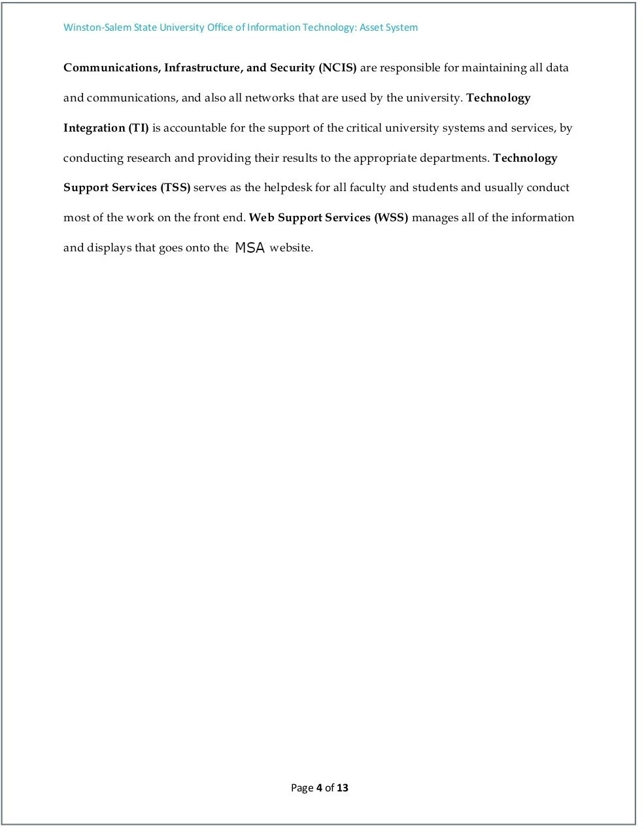

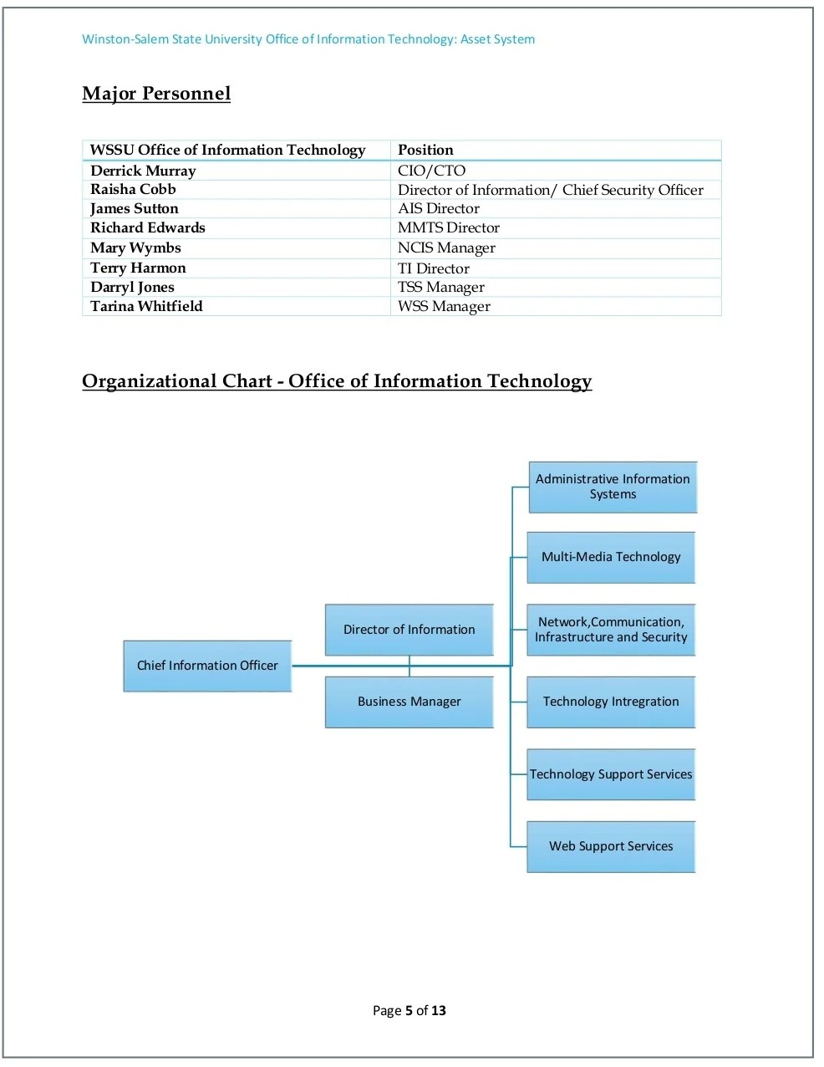

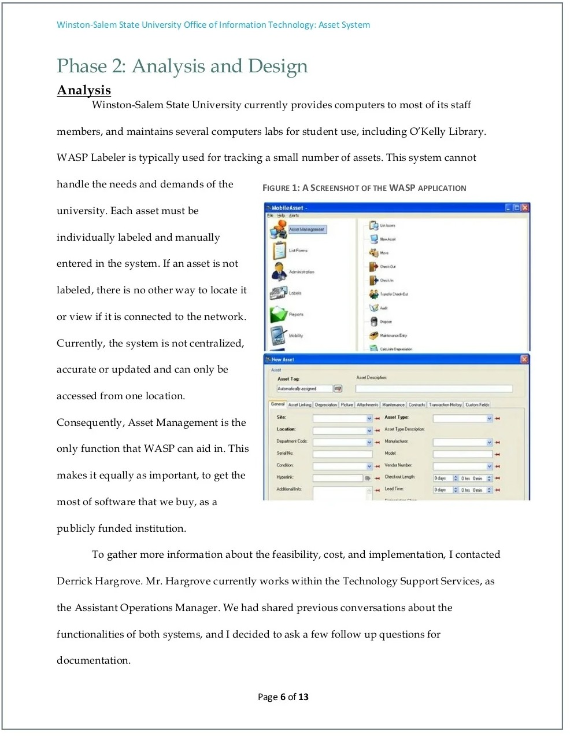

Phase 2: Analysis and Design Analysis

MSA University currently provides computers to most of its staff

members, and maintains several computers labs for student use, including the Library. WASP Labeler is typically used for tracking a small number of assets. This system cannot handle the needs and demands of the university. Each asset must be individually labeled and manually entered in the system. If an asset is not labeled, there is no other way to locate it or view if it is connected to the network. Currently, the system is not centralized, accurate or updated and can only be accessed from one location. Consequently, Asset Management is the only function that WASP can aid in. This makes it equally as important, to get the most of software that we buy, as a publicly funded institution. To gather more information about the feasibility, cost, and implementation, I contacted the CIO of the control. currently works within the Technology Support Services(The Control), as the Assistant Operations Manager. We had shared previous conversations about the functionalities of both systems, and I decided to ask a few follow up questions for documentation.

Page 6 of 13

Interview with The CIO Of The Control

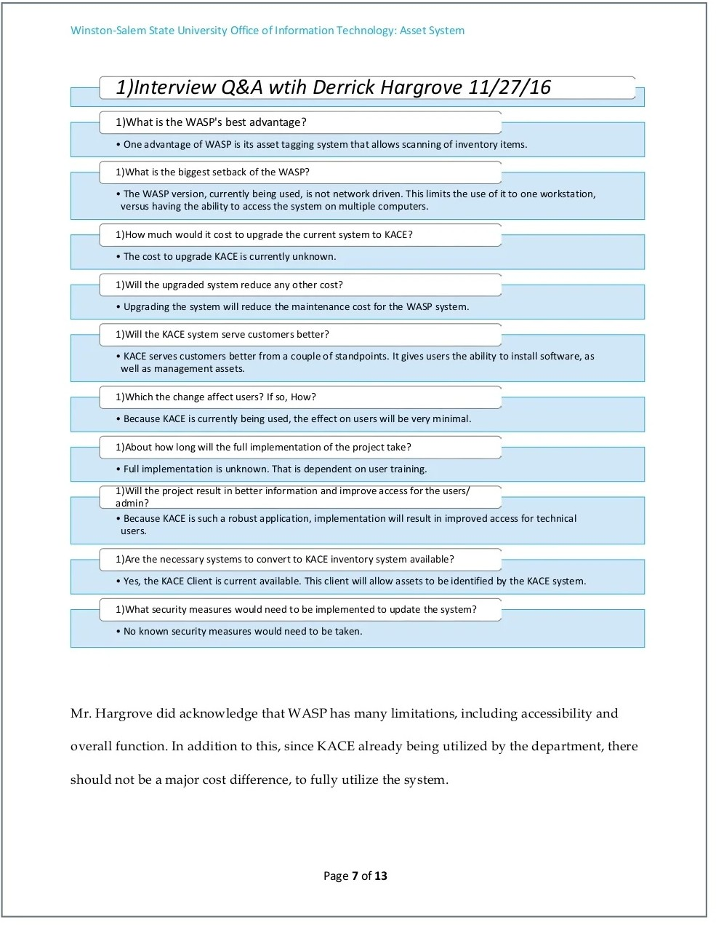

The CIO did acknowledge that WASP has many limitations, including accessibility and overall function and overall function. In addition to this, since KACE already being utilized by the department, there should not be a major cost difference, to fully utilize the system.

Page 7 of 13

